Personal Resilience Action Plan

Developing Your Personal Resilience
Developing resilience equips us with the tools and mindset to cope with various challenges, setbacks and stressful situations. It will help you to adapt to change and keep a positive outlook.

This guide will support you to develop your own resilience action plan and navigate the ups and downs of your current situation more effectively.

We have included some examples taken from a couple of the scenarios we shared in the webinar to support you when working through your own action plan.

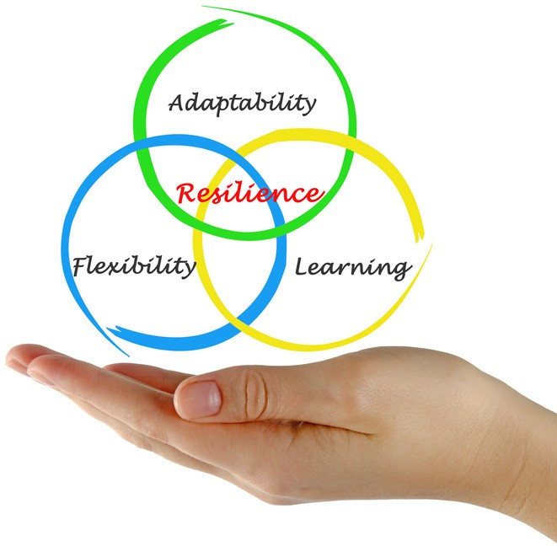

Preparation Steps
Reflection is an important part of building your resilience so that you know which areas you need to improve.

Below are the steps that we used during the webinar to explore how each of the characters could respond better to their current situation.

Activity: Take some time to reflect on the steps below.

Steps | Reflections
1 | Define your current situation.  What change are you experiencing?
2 | Reflect on what have been your  initial reactions during this period?
3 | How do you feel?
4 | How could you respond to  support yourself better?
5 | What are your self-care goals/commitments?

My Resilience Action Plan

You can now use your reflections to work through the following key areas to support your resilience. We have included examples against each area to support you.

(Please also refer to pages 8 and 9 of this guide).

Self-Care Strategies
What has supported you previously in a challenging situation? Think about what helps you to feel better and maintain a balanced mental state.

e.g. Listening to music, going for a walk).

Solution Focused
What different actions could you take today that you haven't explored yet? Is there one small step you could start to take outside your comfort zone?

(Refer to the example pages if you need any help).

Support System
Who can help and encourage you? Think about who has supported you in the past. Meaningful connections are important.

(e.g Friend, family member, therapist. Refer to the example pages if you need any help).

Inspiration
What gives you comfort and keeps you going when things are difficult?

(e.g. A motivational quote, music, affirmation. Refer to the example pages if you need any help).

Examples: Seeking Employment

Below are some examples taken from Laura's case study to support you. As a reminder, Laura had been out of work for months and was struggling to stay motivated.

Self-Care Strategies
- Going for a walk helps to clear my head when I'm feeling frustrated.
- I am going to commit to reading before bed to help me relax.

Solution Focused
- I could ask for feedback following future job interviews.
- I am going to keep focused on my strengths - look at past feedback from others as a reminder.
- I am going to explore different approaches e.g. contacting companies direct and setting a weekly goal.

Support System
- I regularly speak to my partner for support.
- I could also seek support from the talk employment services for advice on looking for work.

Inspiration
- I am going to start listening to a personal development podcast to give me some morning motivation.
- I will keep reminding myself that the right role will come.

Examples: In Employment
Below are some examples taken from Richard's case study to support you. As a reminder, Richard was stressed due to his heavy workload.

Self-Care Strategies
Ensure I take a proper lunch break and get away from my desk each day.
I am committed to going out for a run two evenings a week to help clear my head.

Solution Focused
I will arrange a meeting with my manager to talk about my workload.
Regularly review my priorities and see if there are things I can say ‘no’ to.

Support System

My wife is very supportive so I will continue to speak to her and a trusted colleague at work.
- I am going to contact my GP and share how I'm really feeling and see what their recommendations are.

Inspiration
- I am going to explore some stress management techniques to support my mental health.
Listen to a motivating audio book on my commute.

Goal Setting
T
Throughout this guide you have pulled together some strategies and actions that will help you to develop your resilience. Now you can break these down into actionable steps to help you implement your plan.

Use the SMART structure below to help you create some meaningful goals to support you on your journey.

SPECIFIC | What exactly do I want to achieve in terms of resilience? Why is this important?
MEASURABLE | How will I know that it has been achieved? E.g. use a scale to measure how you feel at the start and have regular check in points.
ACHIEVABLE | Actions to take, to achieve the goal. Make sure the goal could be reasonably achieved.
RELEVANT | Is the goal relevant to your own resilience plan and align with your personal needs?
TIME-BASED | Set a specific timeframe for achieving the goal. This will help you to prioritise.

My Goals

My goals are...

We hope you have enjoyed creating your own personal resilience action plans. Your plan will help you to stay focused and committed to your well-being and personal growth during these times of change.

Good luck implementing your plans. Be patient with yourself as building resilience takes time and practice.

Don't forget to celebrate your achievements along the way, no matter how small.

